

***School of Mechanical & Manufacturing Engineering (SMME),***

***National University of Science and Technology (NUST),***

***Sector H-12, Islamabad***

Program: BE-Aerospace Section: AE-01

Session: Fall 2023 Semester: 1st

Course Title: Fundamentals of Programming (CS-109)

**Lab**

**Assignment # 1**

***Name: Muhammad Arriyaan Ali***

***CMS: 456787***

# **Question 1.** Write a C++ program, take two strings as input from user and check if both strings are equal or not. If they are equal, make them unequal by rotating string. e.g., Hello is turned into olleH etc.

**Code:**

*#include <iostream>*

*#include <string>*

*using namespace std;*

*string reverseString(string str) {*

*int n = str.length();*

*for(int i = 0; i < n / 2; i++) {*

*char temp = str[i];*

*str[i] = str[n - i - 1];*

*str[n - i - 1] = temp;*

*}*

*return str;*

*}*

*int main() {*

*string str1, str2;*

*cout << "Enter first Word(string): "<<endl;*

*cin >> str1;*

*cout << "Enter second Word(string): "<<endl;*

*cin >> str2;*

*if(str1 == str2) {*

*cout << "Both strings are equal. Rotating the first string..."<<endl;*

*str1 = reverseString(str1);*

*cout << "String after rotation: " <<endl<< str1 << endl;*

*} else {*

*cout << "Strings are not equal"<<endl;*

*}*

*return 0;*

*}*

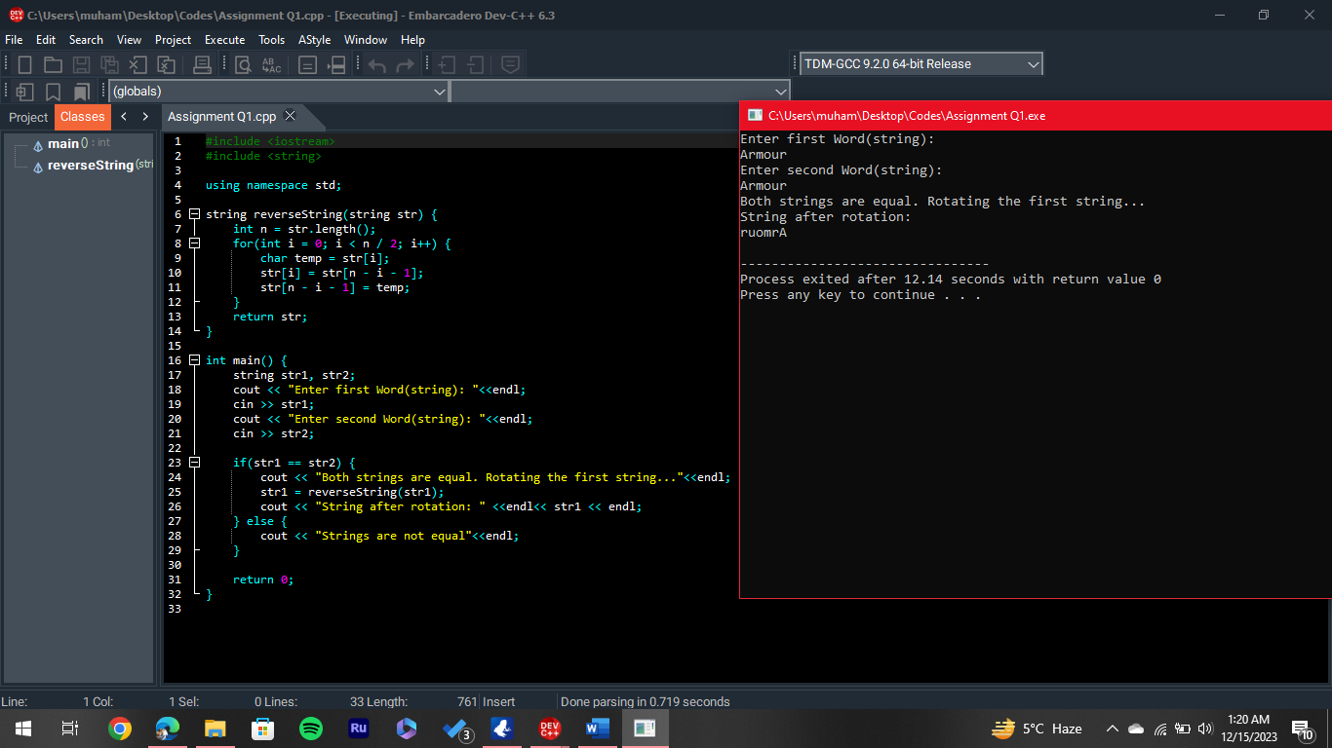**Output:**

Output 1

# **Question 2.** Write a C++program for a string which may contain lowercase and uppercase characters. The task is to remove all duplicate characters from the string and find the resultant string.

**Code:**

*#include <iostream>*

*using namespace std;*

*char *removeDuplicate(char str[], int n)*

*{*

*int index = 0;*

*for (int i=0; i<n; i++) {*

*int j;*

*for (j=0; j<i; j++)*

*if (str[i] == str[j])*

*break;*

*if (j == i)*

*str[index++] = str[i];*

*}*

*return str;*

*}*

*int main()*

*{*

*char str[]= "Gratitude";*

*int n = 10;*

*cout << removeDuplicate(str, n);*

*return 0;*

*}*

# **Output:**

Output 2

# **Question 3.** Suppose an integer array a[5] = {1,2,3,4,5}. Add more elements to it and display them in C++.

**Code:**

*#include <iostream>*

*using namespace std;*

*int main()*

*{ int a[5]={1,2,3,4,5};*

*int n=5; //n = number of elements of array a*

*int b[10];*

*for(int i=0; i<n ; i++)*

*{ b[i]=a[i]; }*

*b[n]=6;*

*b[n+1]=7;*

*b[n+2]=8;*

*n=n+3;*

*cout<<"The new elements of the Array are :"<<endl;*

*for(int i=0; i<n ; i++)*

*{ cout<<b[i]<<endl; }*

*return 0; }*

**Output:**

Output 3

Output 4

# **Question 4.** Write a C++ program that uses a while loop to find the largest prime number less than a given positive integer N. Your program should take the value of N as input from the user and then find the largest prime number less than or equal to N. You are not allowed to use any library or pre-existing functions to check for prime numbers.

**Code:**

#include <iostream>

using namespace std;

int main() {

int N, i;

cout << "Enter a Positive Integer: "<<endl;

cin >> N;

for (; N > 1; N--) {

for (i = 2; i * i <= N; i++) {

if (N % i == 0)

break;

}

if (i * i > N) {

cout << "The Largest Prime Number less than or equal to your input number is : " <<endl<< N << endl;

return 0;

}

}

cout << "There are no prime numbers less than or equal to your number." << endl;

return 0;

}

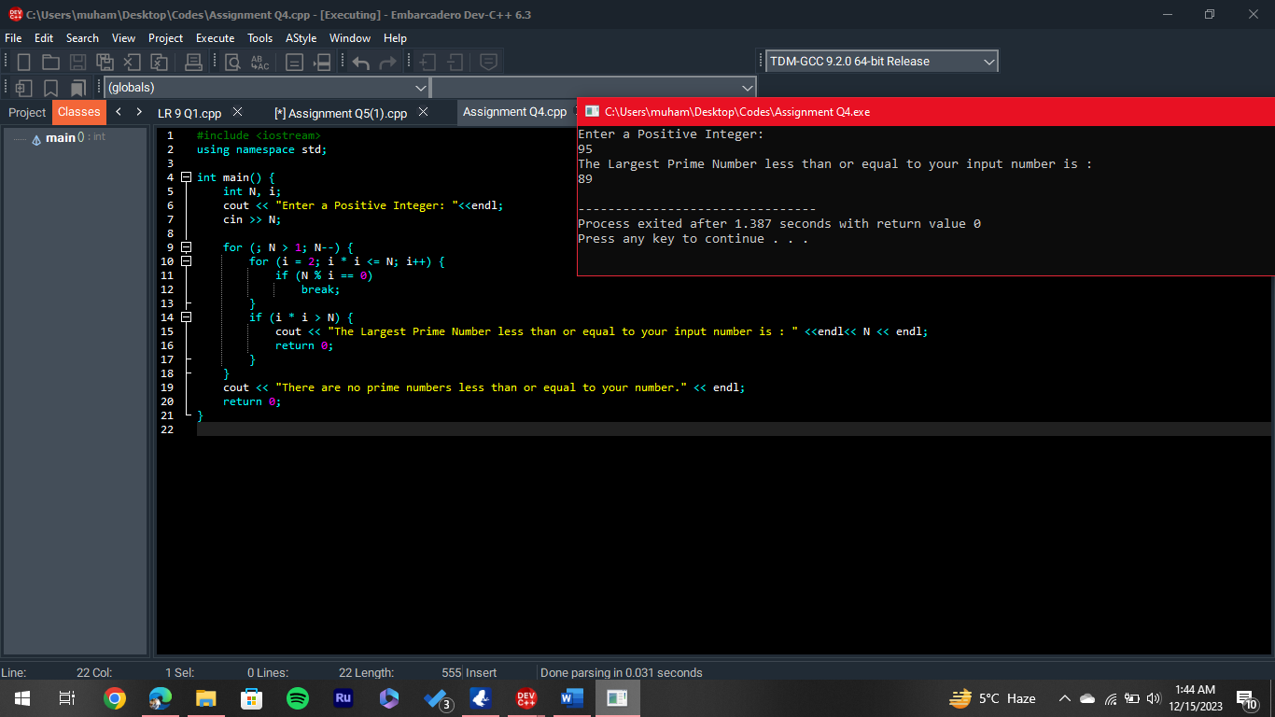**Output:**

Output 5

# **Question 5.** Implement Bubble Sort on an array of 6 integers.

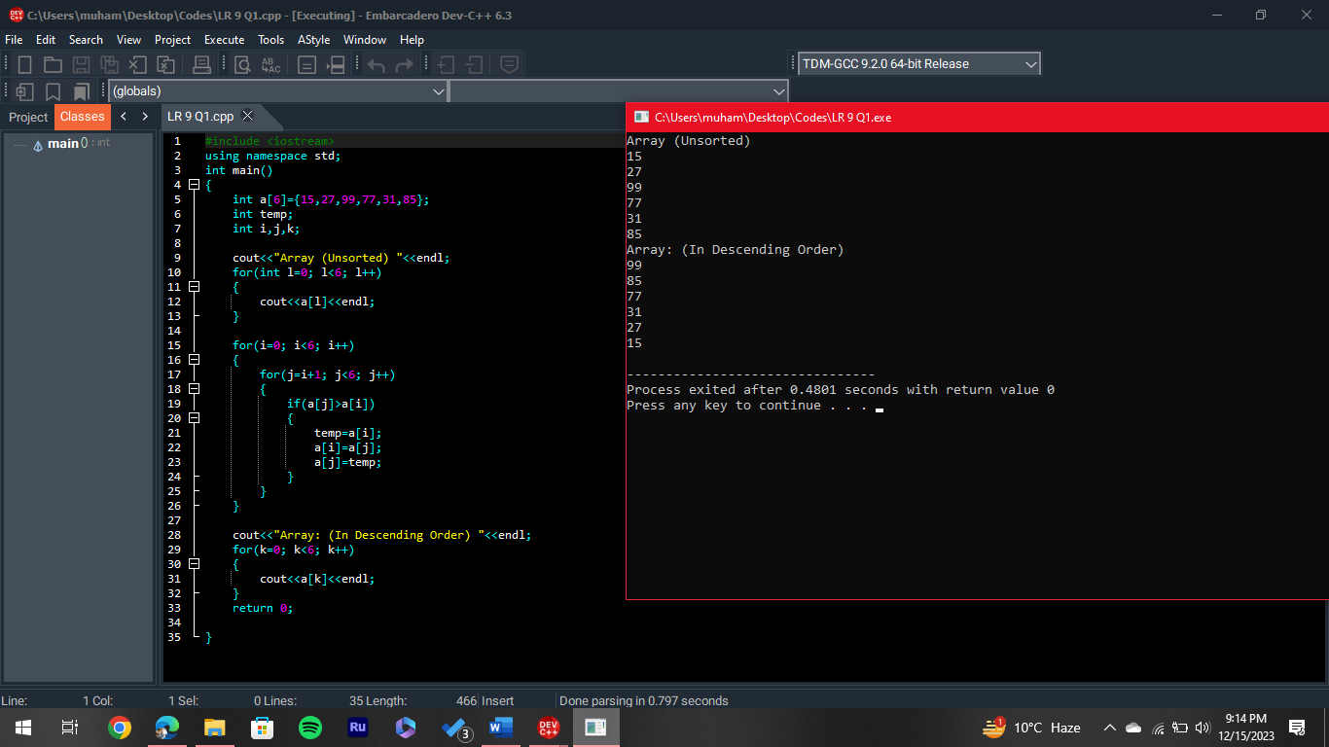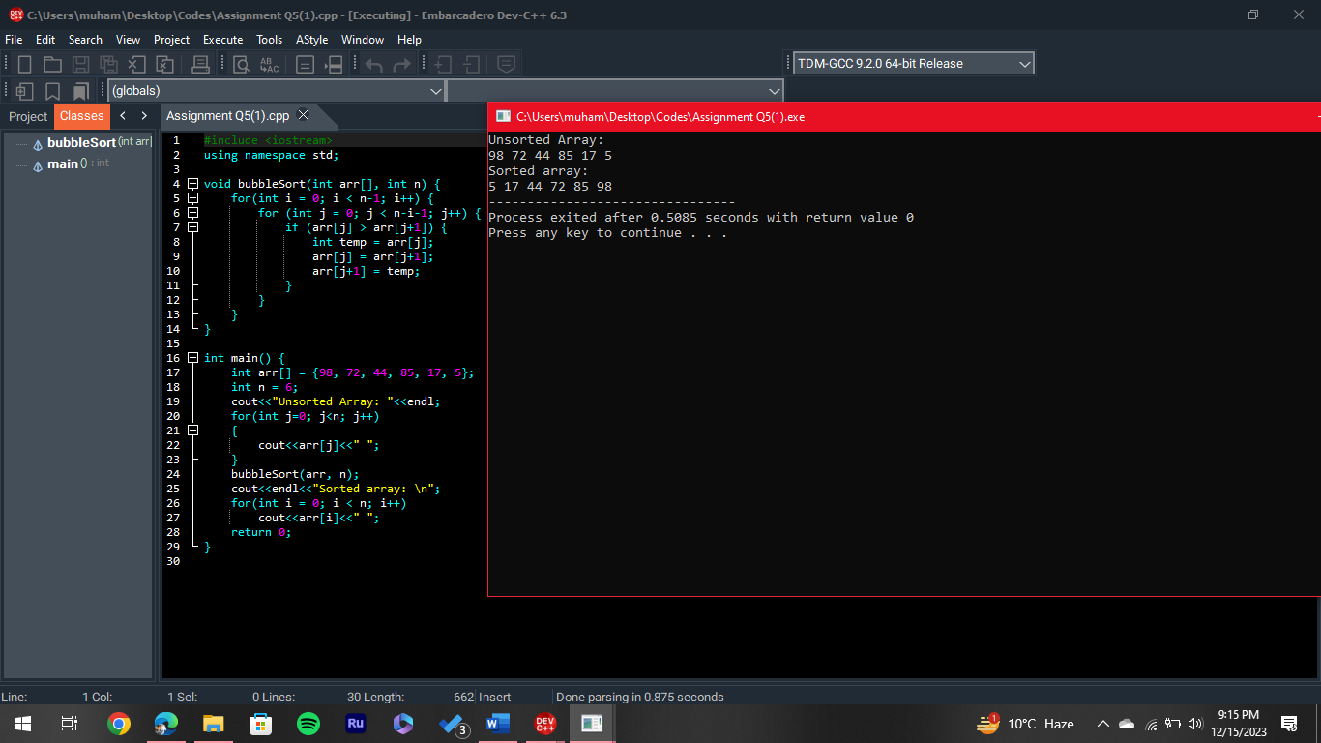**Output:**

Output 5: Variation 2

Output 5: Variation 1

**Code:**

Variation 1:

*#include <iostream>*

*using namespace std;*

*void bubbleSort(int arr[], int n) {*

*for(int i = 0; i < n-1; i++) {*

*for (int j = 0; j < n-i-1; j++) {*

*if (arr[j] > arr[j+1]) {*

*// Swap arr[j] and arr[j+1]*

*int temp = arr[j];*

*arr[j] = arr[j+1];*

*arr[j+1] = temp;*

*}}}}*

*int main() {*

*int arr[] = {98, 52, 74, 85, 12, 5};*

*int n = 6;*

*cout<<"Unsorted Array: "<<endl;*

*for(int j=0; j<n; j++)*

*{ cout<<arr[j]<<" "; }*

*bubbleSort(arr, n);*

*cout<<endl<<"Sorted array: \n";*

*for(int i = 0; i < n; i++)*

*cout<<arr[i]<<" ";*

*return 0;*

*}*

Variation 2:

*#include <iostream>*

*using namespace std;*

*int main()*

*{ int a[6]={15,27,99,77,31,85};*

*int temp;*

*int i,j,k;*

*cout<<"Array (Unsorted) "<<endl;*

*for(int l=0; l<6; l++)*

*{ cout<<a[l]<<endl; }*

*for(i=0; i<6; i++)*

*{*

*for(j=i+1; j<6; j++)*

*{*

*if(a[j]>a[i])*

*{*

*temp=a[i];*

*a[i]=a[j];*

*a[j]=temp;*

*}*

*}*

*}*

*cout<<"Array: (In Descending Order) "<<endl;*

*for(k=0; k<6; k++)*

*{*

*cout<<a[k]<<endl;*

*}*

*return 0; }*

*}*

**Question 6.** Solve any Aerospace/Real Life Problem using C++.

**Building a Stall Velocity calculator:**

**Code:**

*#include <iostream>*

*#include <cmath>*

*using namespace std;*

*float StallVelocity(float p, float l, float s, float cl)*

*{*

*double V= sqrt(2*l/(cl*p*s));*

*return V;*

*}*

*int main()*

*{*

*float rho;*

*float L;*

*float Cl;*

*float S;*

*float V;*

*cout<<"Enter The Lift Force (L):"<<endl;*

*cin>>L;*

*cout<<"Enter Coefficent of Lift (Cl):"<<endl;*

*cin>>Cl;*

*cout<<"Enter Area of Wing (S): "<< endl;*

*cin>>S;*

*cout<<"Enter Density of Air (rho): "<<endl;*

*cin>>rho;*

*V=StallVelocity(rho, L, S, Cl);*

*cout<<"The Stall Velocity for the above parameters of an airfoil will be: "<<endl<<V<<" m/s";*

*return 0;*

*}*

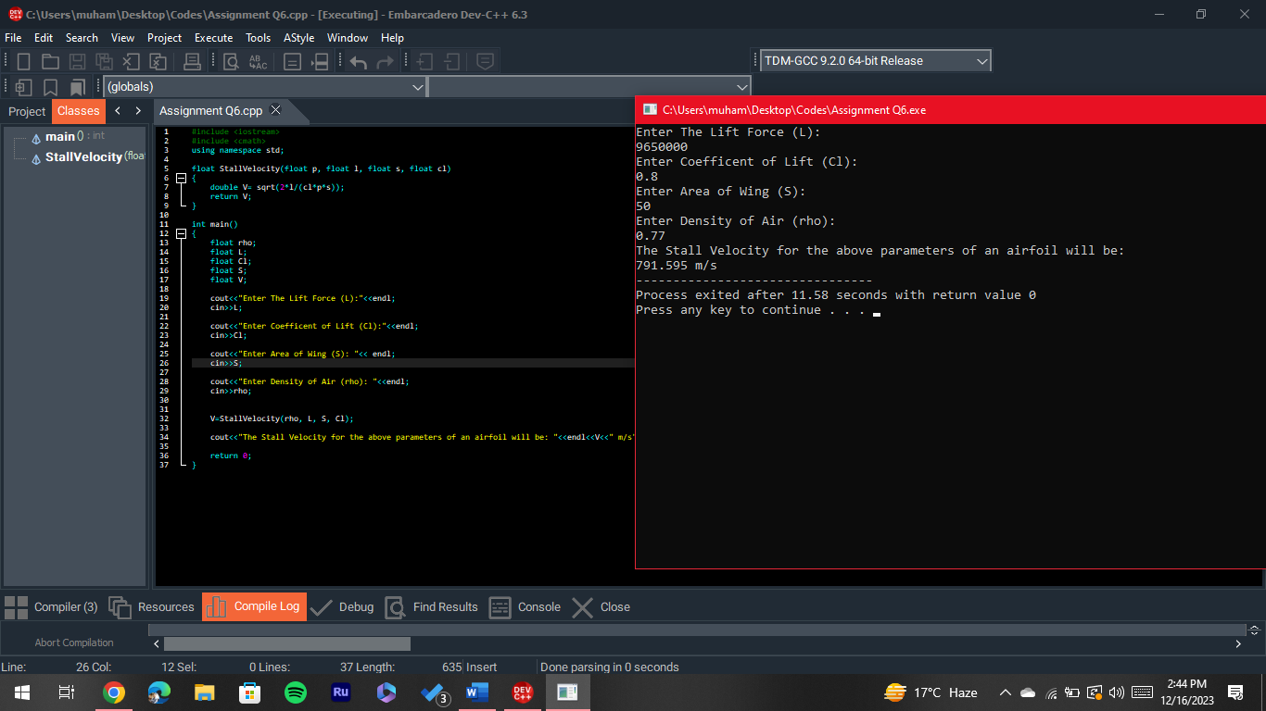**Output:**

Output 6